Test Case: tc001_SPX_Dev5_Crear_Solicitud_Articulo_Almacen
Step 1 - Enter username and password and click to button Enter : Credentials Entered
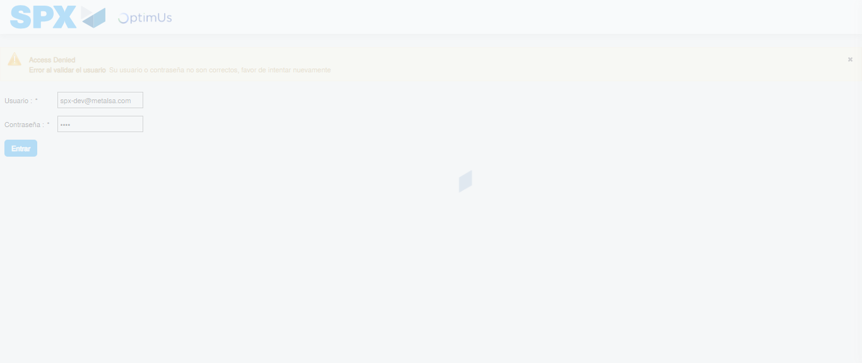Image file-name: QC_Testing-tc001_SPX_Dev5_Crear_Solicitud_Articulo_Almacen-1787932534128

Step 2 - Select to UEN and Access to Request for a New Inventory Item : UEN Correctly selected and Correct access
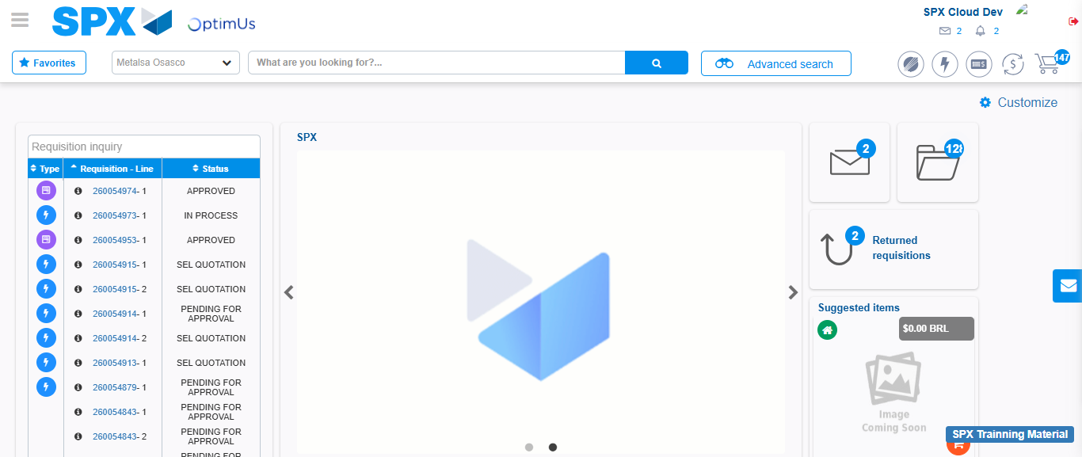Image file-name: QC_Testing-tc001_SPX_Dev5_Crear_Solicitud_Articulo_Almacen-1787932559247

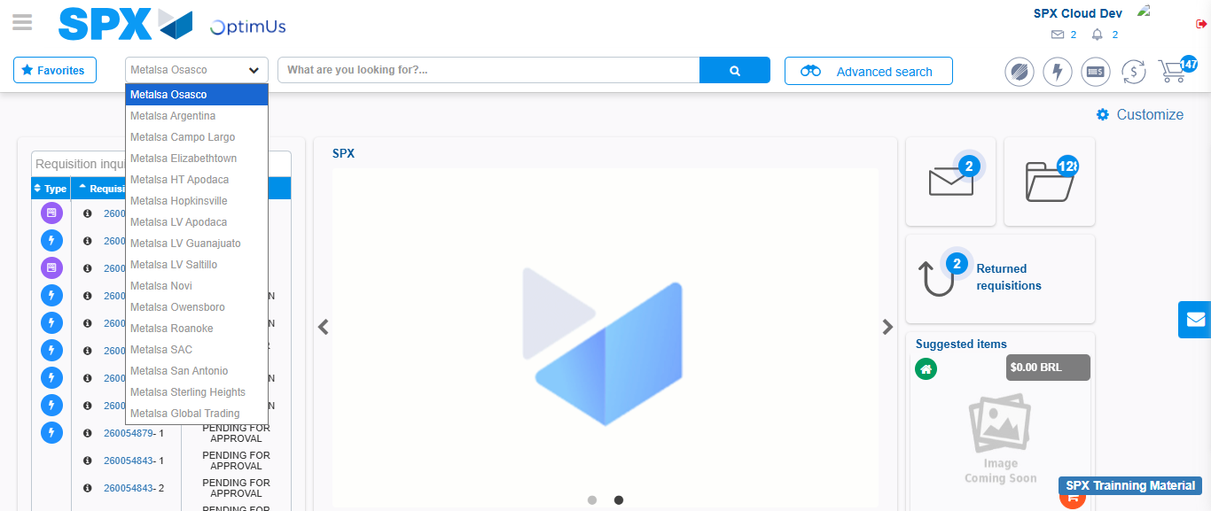Image file-name: QC_Testing-tc001_SPX_Dev5_Crear_Solicitud_Articulo_Almacen-1787932559764

Image file-name: QC_Testing-tc001_SPX_Dev5_Crear_Solicitud_Articulo_Almacen-1787932581620

Step 3 - Select options first section : Options seleted correctly
Image file-name: QC_Testing-tc001_SPX_Dev5_Crear_Solicitud_Articulo_Almacen-1787932581828

Image file-name: QC_Testing-tc001_SPX_Dev5_Crear_Solicitud_Articulo_Almacen-1787932582009

Step 4 - Select options at Screen: Options seleted correctly
Image file-name: QC_Testing-tc001_SPX_Dev5_Crear_Solicitud_Articulo_Almacen-1787932581828

Image file-name: QC_Testing-tc001_SPX_Dev5_Crear_Solicitud_Articulo_Almacen-1787932582009

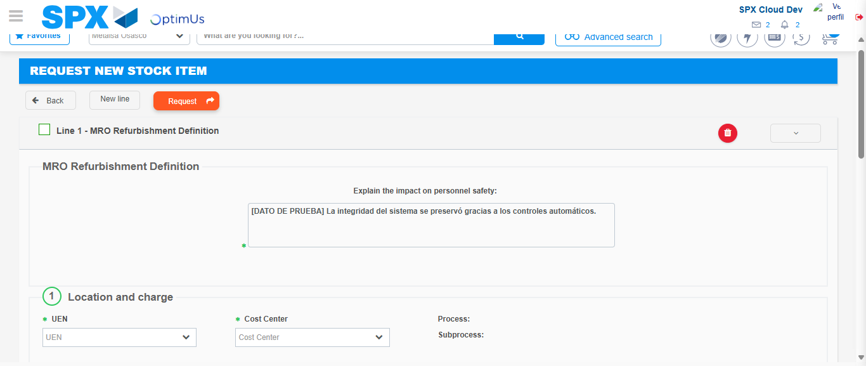Image file-name: QC_Testing-tc001_SPX_Dev5_Crear_Solicitud_Articulo_Almacen-1787932588208

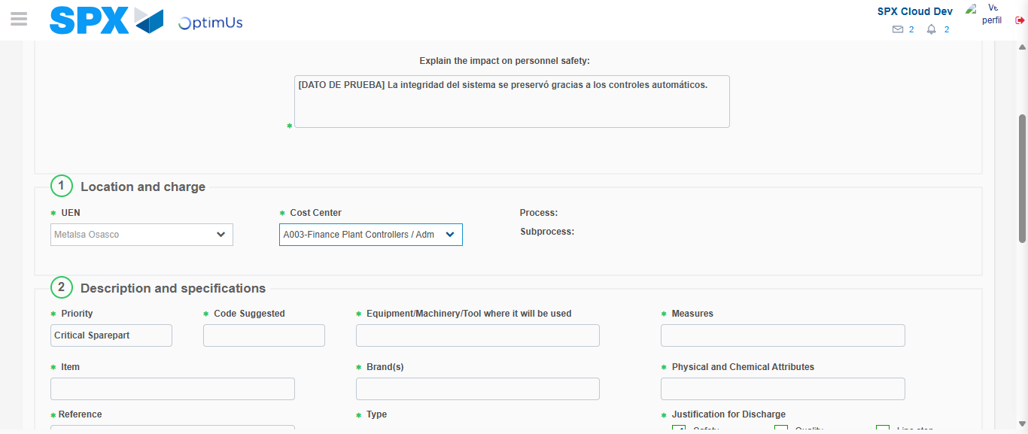Image file-name: QC_Testing-tc001_SPX_Dev5_Crear_Solicitud_Articulo_Almacen-1787932590661

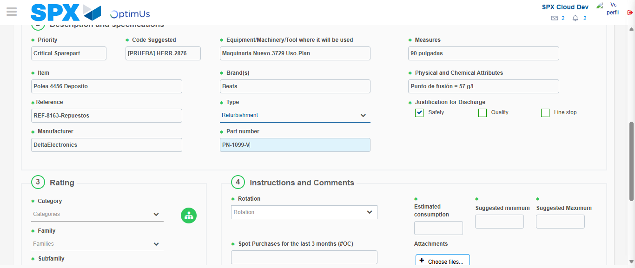Image file-name: QC_Testing-tc001_SPX_Dev5_Crear_Solicitud_Articulo_Almacen-1787932591958

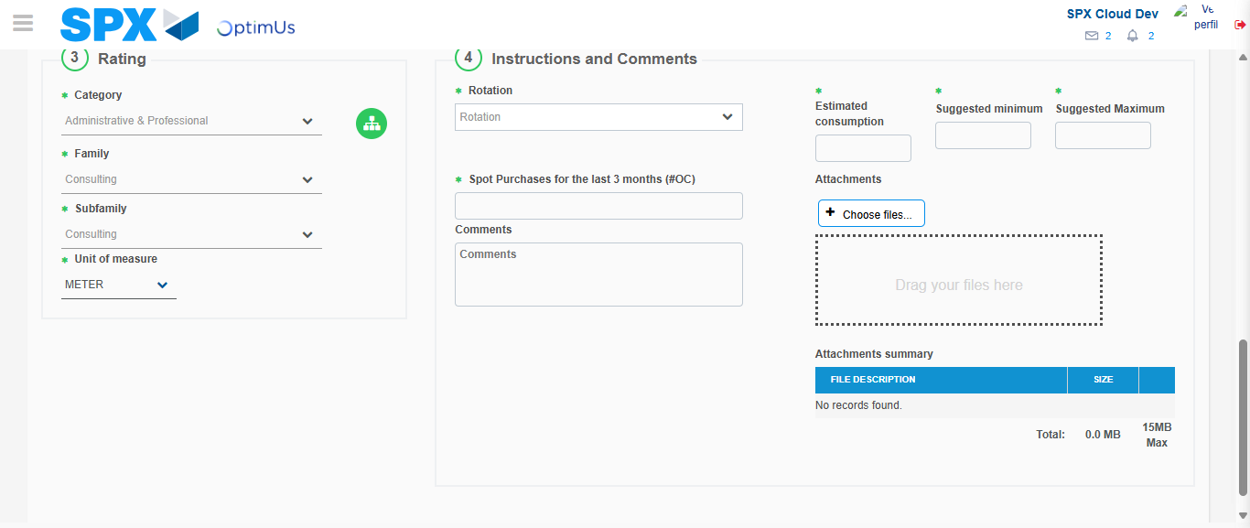Image file-name: QC_Testing-tc001_SPX_Dev5_Crear_Solicitud_Articulo_Almacen-1787932596112

Step 5 - Request New Item : Request Accepted
Image file-name: QC_Testing-tc001_SPX_Dev5_Crear_Solicitud_Articulo_Almacen-1787932559247

Image file-name: QC_Testing-tc001_SPX_Dev5_Crear_Solicitud_Articulo_Almacen-1787932559764

Image file-name: QC_Testing-tc001_SPX_Dev5_Crear_Solicitud_Articulo_Almacen-1787932581620

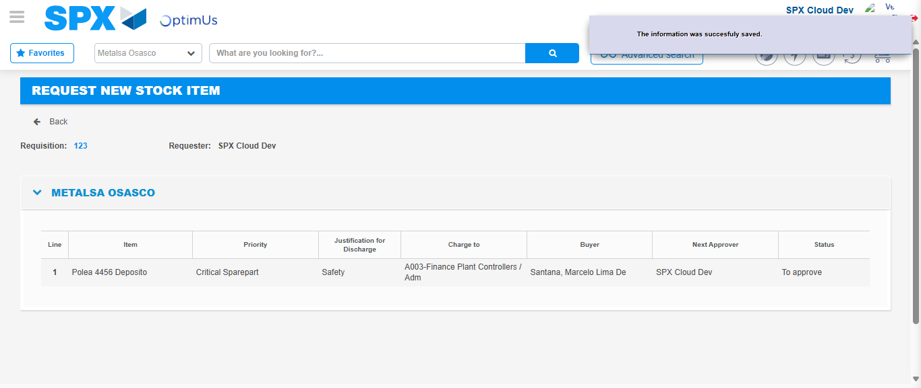Image file-name: QC_Testing-tc001_SPX_Dev5_Crear_Solicitud_Articulo_Almacen-1787932603075

Image file-name: QC_Testing-tc001_SPX_Dev5_Crear_Solicitud_Articulo_Almacen-1787932603229

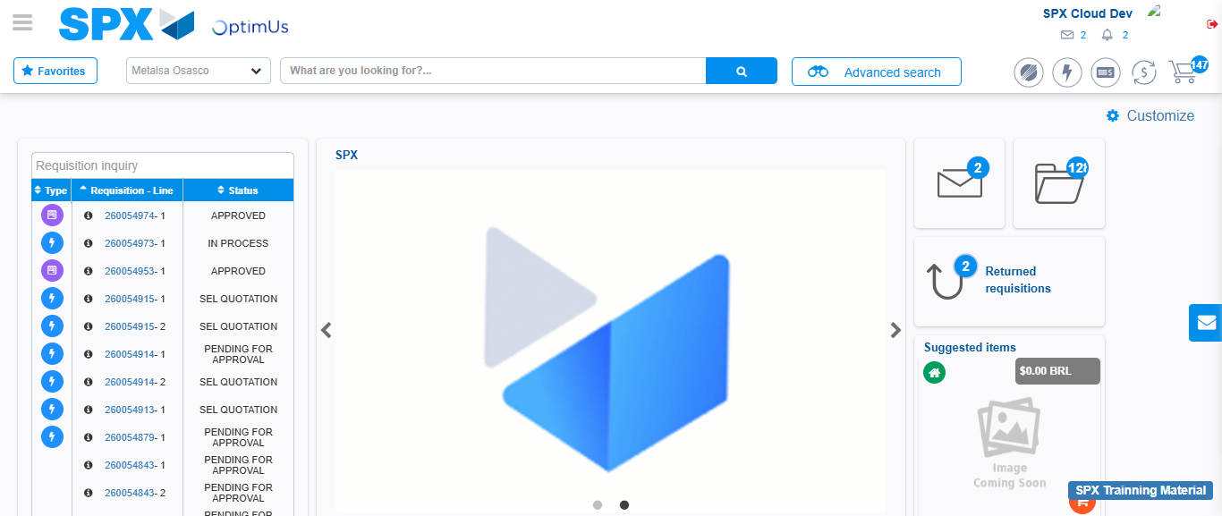Image file-name: QC_Testing-tc001_SPX_Dev5_Crear_Solicitud_Articulo_Almacen-1787932624493

Step 7 - Return to Main Page SPX : Return to Main Page SPX
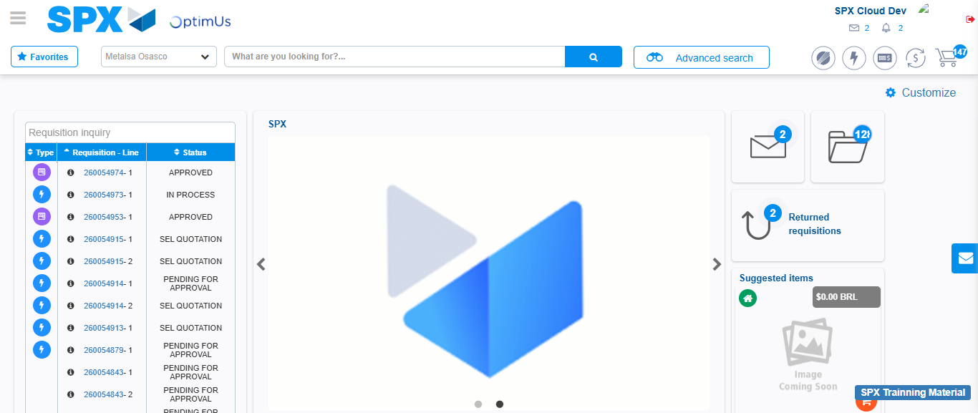Image file-name: QC_Testing-tc001_SPX_Dev5_Crear_Solicitud_Articulo_Almacen-1787932624826

